ECA5604-5G/6G COMMUNICATION SYSTEMS
NAME: V Sadhana
REG NO:192412242
Exp 6: 5G NR Frame Structure Analysis with Different Subcarrier Spacing
Objective – 1
Analyze the standard subcarrier spacing (SCS) values defined in the 5G NR numerology using
MATLAB. Compare the relationship between the numerology index (μ) and subcarrier spacing to
understand the flexible bandwidth allocation employed in 5G communication systems.
Code:
clc;
clear;
close all;
scs = [15 30 60 120 240]; % Subcarrier Spacing (kHz)
mu = 0:4; % Numerology Index
bar(scs)
grid on
set(gca,'XTick',1:5)
set(gca,'XTickLabel',mu)
xlabel('Numerology Index (\mu)')
ylabel('Subcarrier Spacing (kHz)')
title('5G NR Subcarrier Spacing for Different Numerologies')
output:

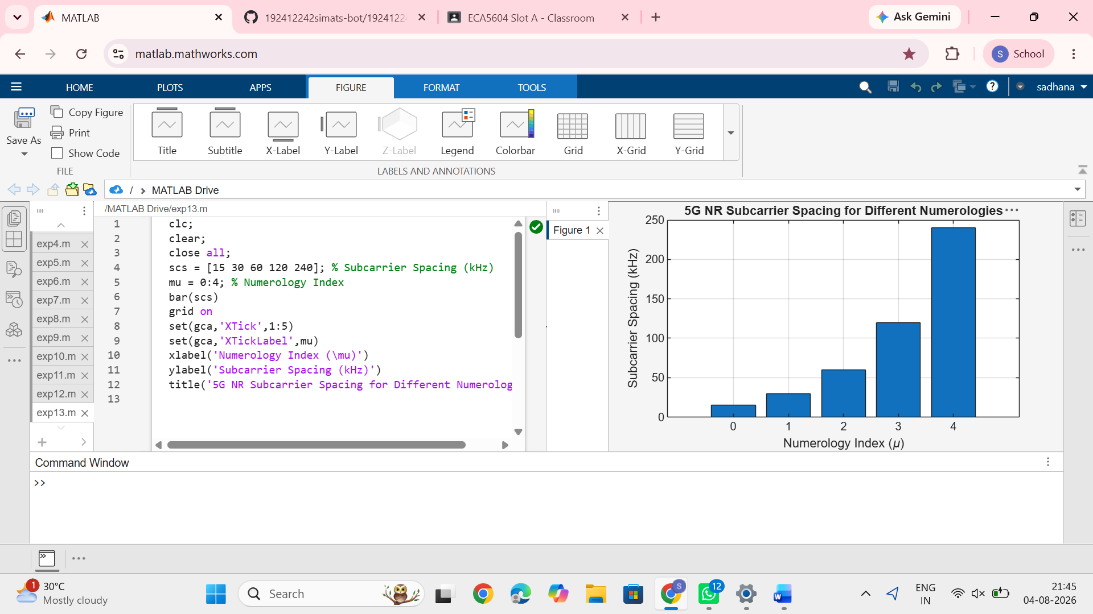

Objective – 2 Compare Slot Duration
Analyze the variation in slot duration corresponding to different 5G NR subcarrier spacing values
using MATLAB. Compare the inverse relationship between subcarrier spacing and slot duration
to understand how flexible numerology enables low-latency communication in 5G networks.
Code:
clear;
close all;
scs = [15 30 60 120 240]; % Subcarrier Spacing (kHz)
slot = [1 0.5 0.25 0.125 0.0625]; % Slot Duration (ms)
plot(scs, slot, 'o-', 'LineWidth', 2)
grid on
xlabel('Subcarrier Spacing (kHz)')
ylabel('Slot Duration (ms)')
title('5G NR Slot Duration for Different Subcarrier Spacing')
output:
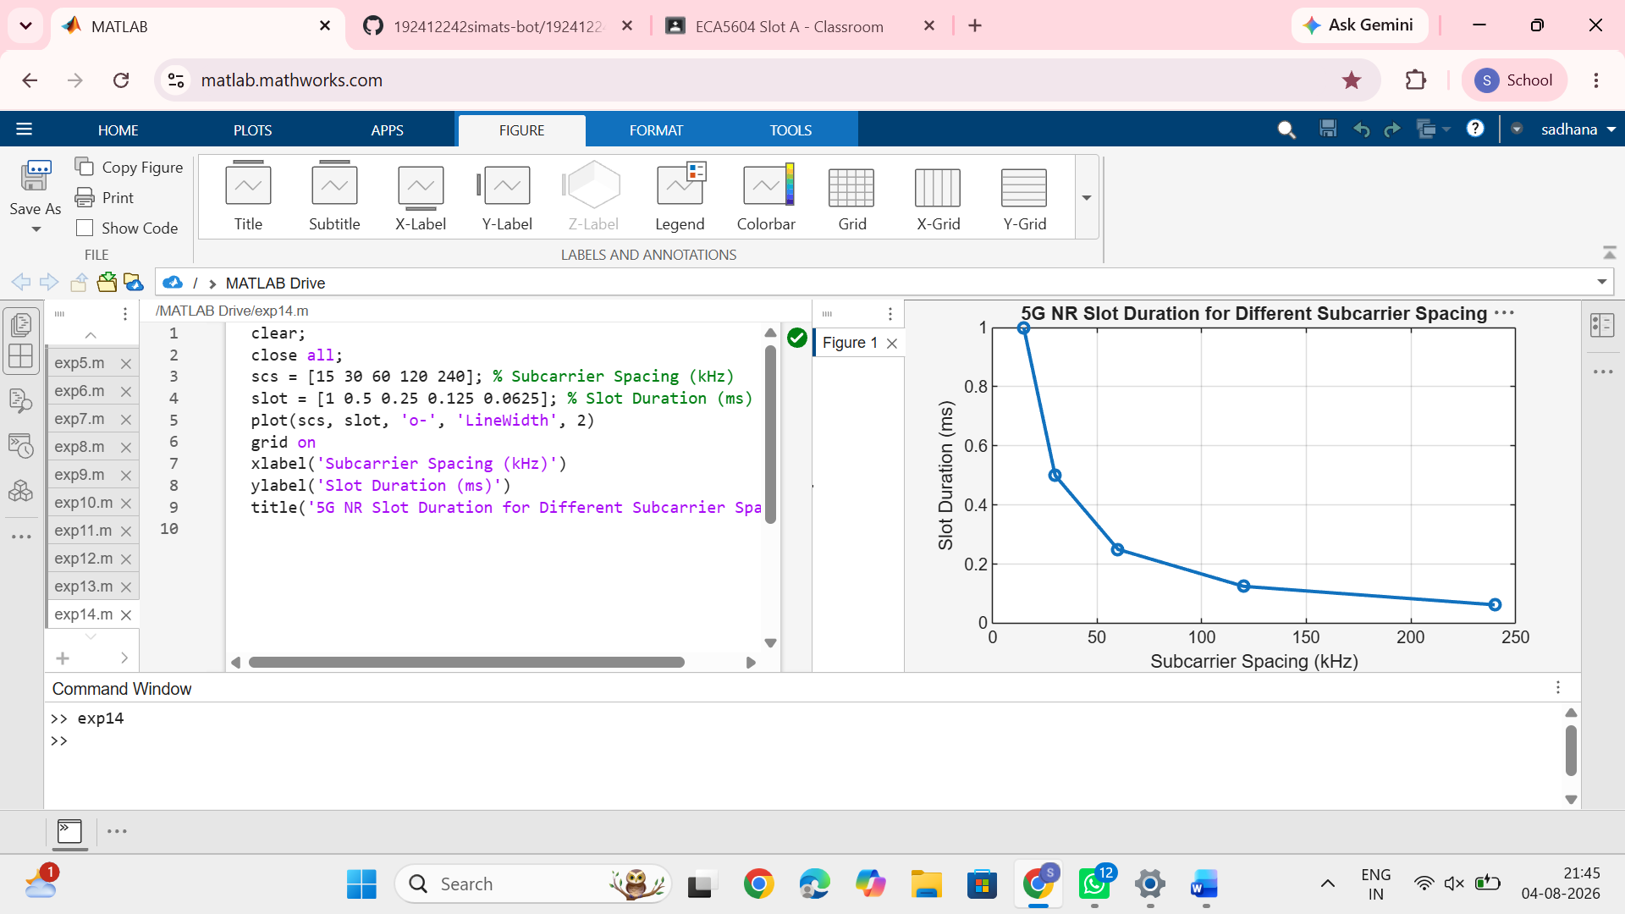

Objective – 3 Study the Number of OFDM Symbols
Analyze the number of OFDM symbols present in a 5G NR slot for different numerology
configurations using MATLAB. Observe that, under the normal cyclic prefix, each slot
consistently contains 14 OFDM symbols irrespective of the subcarrier spacing.
Code:
clc;
clear;
close all;
scs = [15 30 60 120 240]; % Subcarrier Spacing (kHz)
symbols = [14 14 14 14 14]; % OFDM Symbols per Slot
figure
bar(scs, symbols)
grid on
xlabel('Subcarrier Spacing (kHz)')
ylabel('Number of OFDM Symbols')
title('OFDM Symbols per Slot for Different Subcarrier Spacing')
ylim([0 16])
output:
